Christopher Columbus: Hero or Villain?
Columbus Day churns up a stormy sea of controversy every year.
B. MYINT
OCT 12, 2015
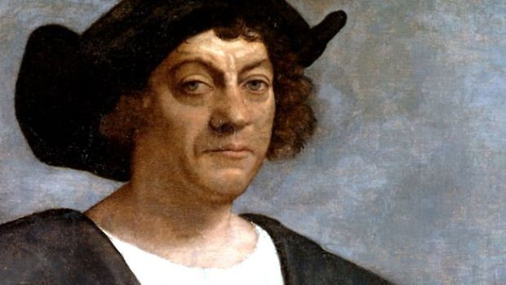
Christopher Columbus (Image: Sebastiano del Piombo [Public domain], via Wikimedia Commons)

Whether you call it Columbus Day or Indigenous People’s Day, one thing is for sure -- today’s holiday churns up a sea of debate that could capsize even the Santa Maria. While many schoolbooks present Christopher Columbus as the famous Italian explorer who discovered America, history has painted a much more complicated picture. Was the man from Genoa a brave explorer or greedy invader? A gifted navigator or reckless adventurer? Here are some things to consider the next time you hear someone recite: In 1492, Columbus sailed the ocean blue...

Columbus never discovered America
Even if you were to overlook the not-so-minor fact that millions of people were already living in North America in 1492, the fact is that Columbus never set foot on our shores. In fact, October 12th marks the day of his arrival to the Bahamas. While he did reach the coasts of what today are Cuba, Haiti, and the Dominican Republic, as well as explore the Central and South American coasts, he never unfurled a Spanish flag in North America. (Leif Eriksson is the first European believed to have sailed to North America, having reached Canada 500 years before Columbus set sail to the west.)

...but his voyage was no less courageous
He may never have reached Asia as planned, but one cannot discount the sheer will required to make his journey. At the age of 41, he defied naysayers across Europe and led four voyages across an uncharted ocean in wooden sailing ships that were not designed to take on the punishing waters of the Atlantic.

The world already believed the world was round
By 1492, most educated Europeans already believed the earth was round. In fact, it was an idea that had been established by the Ancient Greeks in the 5th Century BC. Contrary to popular myth, Columbus did not set out to prove that the world was round, but rather that it was possible to sail around it, a voyage the explorer drastically underestimated.
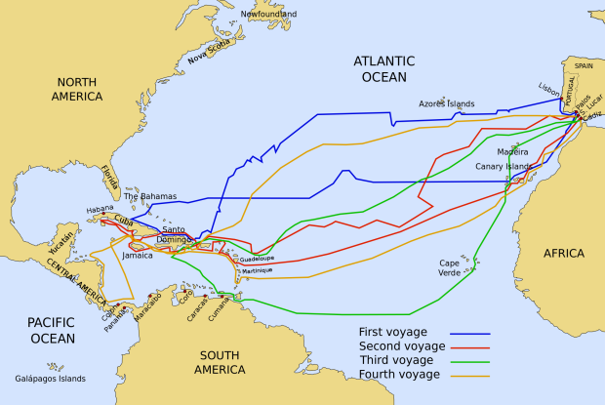
The voyages of Columbus. (Image: Viajes_de_colon.svg: Phirosiberia derivative work: Phirosiberia (Viajes_de_colon.svg) [CC BY-SA 3.0 or GFDL], via Wikimedia Commons)

He had struck a lucrative deal with the Spanish
Christopher Columbus stood to gain significant wealth and power from his voyage, terms he negotiated with King Ferdinand and Queen Isabella of Spain. His contract with the monarchs, called The Capitulations of Santa Fe, named Columbus the admiral, viceroy, and governor of any land he discovered. It also stated that Columbus could keep 10 percent of any “merchandise, whether pearls, precious stones, gold, silver, spices and other objects” that he “acquired” within the new territory. Columbus may indeed have had noble intentions when he sailed west, but his agreement with Spain suggests his intentions were far from selfless.

He enslaved and mutilated native people
When Columbus first set foot on Hispaniola, he encountered a population of native people called the Taino. A friendly group, they willingly traded jewelry, animals, and supplies with the sailors. “They were very well built, with very handsome bodies and very good faces,” Columbus wrote in his diary. “They do not carry arms or know them....They should be good servants.” The natives were soon forced into slavery, and punished with the loss of a limb or death if they did not collect enough gold (a portion of which Columbus was allowed to keep for himself). Between the European’s brutal treatment and their infectious diseases, within decades, the Taino population was decimated.

He was arrested by the Spanish Government
In 1499, the Spanish monarchs got wind of the mistreatment of Spanish colonists in Hispaniola, including the flogging and executions without trial. Columbus, who was governor of the territory, was arrested, chained up, and brought back to Spain. Although some of the charges may have been manufactured by his political enemies, Columbus admitted to King Ferdinand and Queen Isabella that many of the accusations were true. Columbus was stripped of his title as governor.
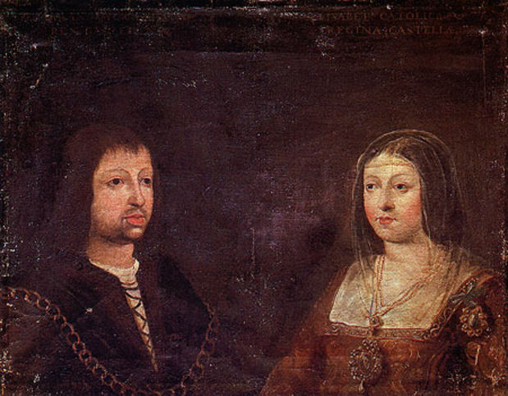
King Ferdinand and Queen Isabella. (Photo: Public domain via Wikimedia Commons)

Several European countries had rejected Columbus
For nearly a decade, Columbus lobbied European monarchs to bankroll his expensive quest to discover a western sea route to Asia. In 1484 he tried unsuccessfully to get support from King John II of Portugal, whose experts believed Columbus had underestimated how far he would need to sail. Three years later, he appealed to King Henry VII of England and King Charles VIII of France but was once again turned down. He was even rejected initially by Spain in 1486, but the Spanish monarchs changed their mind and eventually agreed to fund his trip.

Good or bad, Columbus created a bridge between the old and new world
In what has become known as the Columbian Exchange, Columbus’ voyages enabled the exchange of plants, animals, cultures, ideas (and, yes, disease) between the Western and Eastern Hemispheres. Once the Europeans were able to reach nearly all parts of the globe, a new modern age would begin, transforming the world forever.

