DBQ: Start of the Cold War
(Adapted from Document-Based Assessment for Global History, Walch Education)
Historical Context:
Between 1945 and 1950, the wartime alliance between the United States and the Soviet Union broke down and the Cold War began. For the next 40 years, relations between the two superpowers swung between confrontation and détente. Each tried to increase its worldwide influence and spread its competing economic and political systems. At times during this period the competitors were at the brink of war. How was the Cold War fought?
Directions: The following question is based on the accompanying documents in Part A. As you analyze the documents, take into account both the source of the document and the author’s point of view. Be sure to:
1. Carefully read the document-based question. Consider what you already know about this topic. How would you answer the question if you had no documents to examine?
2. Now, read each document carefully, underlining key phrases and words that address the document-based question. You may also wish to use the margin to make brief notes. Answer the questions which follow each document.
3. Based on your own knowledge and on the information found in the documents, formulate a thesis that directly answers the question.
4. Organize supportive and relevant information into a brief outline.
5. Write a well-organized essay proving your thesis. The essay should be logically presented and should include information both from the documents and from your own knowledge outside of the documents.
Question: How did the Cold War begin and what “weapons” were used to fight this war?
Part A: The following documents provide information about the Cold War. Examine the documents carefully, and answer the questions that follow.
Document 1
This is an excerpt from Winston Churchill’s “Iron Curtain” speech, March 5, 1946.
From Stettin in the Baltic to Trieste in the Adriatic, an iron curtain has descended across the continent. Behind that line lie all the capitals of the ancient states of Central and Eastern Europe… All these famous cities and the populations around them lie in the Soviet sphere and all are subject in one form or another, not only to Soviet influence but to a very high and increasing measure of control from Moscow.
How is the “iron curtain” a dividing line?___________________________________________________ _____________________________________________________________________________________ _____________________________________________________________________________________ _____________________________________________________________________________________

DBQ: The Cold War Begins
Document 2
This is an excerpt from President Truman’s speech to Congress, March 12, 1947.
I believe it must be the policy of the United States to support free peoples who are resisting attempted subjugation [domination] by armed minorities or by outside pressure. Should we fail to aid Greece and Turkey in this fateful hour, the effect will be far-reaching to the West. The seeds of totalitarian regimes are nurtured by misery and want. They spread and grow in the evil soil of poverty and strife. The reach their full growth when the hope of a people for a better life has died. Therefore, I propose giving Greece and Turkey $400 million in aid.
Explain the policy President Truman suggested in this speech. __________________________________ _____________________________________________________________________________________
Document 3
This is an excerpt from Secretary of State Marshall’s speech explaining his plan for European recovery, June 5, 1947.
I need to say that the world situation is very serious… Europe must have a great deal of additional help, or face heavy economic, social, and political damage. This would have a harmful effect on the world at large. There are also possibilities of disturbances because of the desperation of the people concerned. The effect on the economy of the United States should be clear to all. So the United States should do whatever it can to help restore normal economic health to the world. Without this there can be no political stability or peace. Our policy is directed…against hunger, poverty, desperation and chaos [disorder]. Its purpose is to revive a working economy in the world.
Why did Secretary of State Marshall suggest this plan for European recovery? _____________________ _____________________________________________________________________________________
Document 4
This is an excerpt from the North Atlantic Treaty, which was signed by the United States, Canada, and ten nations of Western Europe in 1948.
The parties agree than an armed attack against one or more of them in Europe or in North America shall be considered as an attack against them all. They agree that if such an armed attack occurs, each of them will assist the party or parties so attacked. Each will immediately take whatever action it considers necessary to restore and maintain the security of the North Atlantic area. It will, if necessary, use armed force.
What is the purpose of NATO? ____________________________________________________________ _____________________________________________________________________________________

Document 5
The Soviet Union responded to NATO by creating its alliance, the Warsaw Pact.
NATO Members | Great Britain, Norway, Denmark, Netherlands, Belgium, Republic of Germany, France, Italy, Spain, Turkey, Greece
Warsaw Pact Members | German Democratic Republic, Poland, Czechoslovakia, Hungary, Romania, Bulgaria, Soviet Union
Other Communist Nations | Yugoslavia

How do these “satellites” in the Warsaw Pact provide a buffer for the Soviet Union? ________________ _____________________________________________________________________________________
Document 6
This is an excerpt from a speech by Soviet Premier Nikita Khrushchev in 1956 in which he explains his point of view on U.S. actions.
The inspirers of the “cold war” began to establish military blocs—the North Atlantic bloc, SEATO, and the Baghdad pact. [They claim] they have united for defense against the “communist threat.” But this is sheer hypocrisy! We know from history that when planning a re-division of the world, the imperialist powers have always lined up military blocs. Today the “anti-communism” slogan is being used as a smoke screen to cover up the claims of one power for world domination. The United States wants, by means of blocs and pacts, to secure a dominant position in the capitalist world. The inspirers of the “position of strength” policy assert that it makes another way impossible because it ensures a “balance of power” in the world. [They] offer the arms race as their main recipe for the preservation of peace! It is perfectly obvious that when nations compete to increase their military might, the danger of war becomes greater, not lesser. Capitalism will find its grave in another world war, should it unleash it.
What is Khrushchev’s view of U.S. actions? According to Khrushchev what will happen? _____________________________________________________________________________________ _____________________________________________________________________________________ _____________________________________________________________________________________
Document 7
The arms race was an important part of the Cold War. Both superpowers developed technology and used their nuclear power to build as many weapons as possible. This nuclear buildup led to a “balance of terror,” which some saw as a deterrent to war. But others feared the use of these weapons. These charts show the buildup of ICBM’s and long-range bombers between 1966 and 1974.
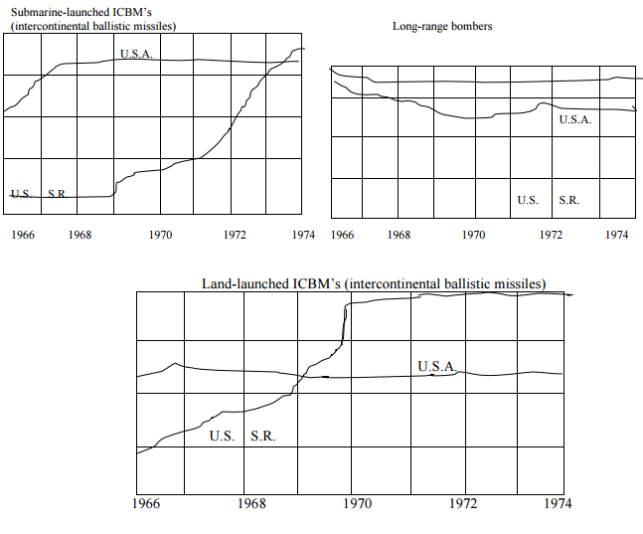
What impact did this arms race have on the world? __________________________________________ _____________________________________________________________________________________ ____________________________________________________________________________________
Document 8
The threat of nuclear was obvious in the Cuban missile crisis of 1962. This excerpt, from President John F. Kennedy’s speech to the American people, explains the U.S. position
…We have unmistakable evidence that a series of offensive missile sites is now being built on that island. …Cuba has been made into an important strategic base by the presence of these long-range offensive weapons of sudden mass destruction. This is an open threat to the peace and security of all of the Americas. Our objective must be to prevent the use of these missiles against this or any other country. We must secure their withdrawal from the Western Hemisphere…I call upon Chairman Khrushchev to halt and eliminate this secret and reckless threat to world peace.
What is the basis for President Kennedy’s demand that the missiles be removed from Cuba? _____________________________________________________________________________________ _____________________________________________________________________________________ _____________________________________________________________________________________
Document 9
After Kennedy ordered a quarantine of all offensive military equipment being sent into Cuba, Premier Khrushchev responded with this message.
Mr. President, the Soviet government decided to help Cuba with means of defense against outside attack. These weapons were only meant for defensive purposes. We have supplied them to prevent aggression against Cuba… With respect and confidence. I accept the statement set forth in your message of October 27, 1962. You said then that Cuba will not be attacked or invaded by any country of the Western Hemisphere… We have given the order to discontinue building the installations. We shall dismantle Document 3them and withdraw them to the Soviet Union. How does Khrushchev explain why missiles were placed in Cuba and why they could now be removed? _____________________________________________________________________________________ _____________________________________________________________________________________ _____________________________________________________________________________________ _____________________________________________________________________________________
Part B—Essay (5 Paragraph)
How did the Cold War begin and what “weapons” were used to fight this war?

