40pts
Fighting in The East & The West
Geography Activity

Directions: Use the information provided in the map on the next page to answer the following questions.
- What states are listed on the map? _________________________________________________

- In what state did the Battle of Gettysburg take place? ___________________________________

- In which state did the Battle of Antietam take place? ___________________________________

- Which army won the Battle of Gettysburg? ___________________________________________

- Which army won the Battle of the Wilderness? _______________________________________

- Which army won the Battle of Durham Station? _______________________________________

- Which army won the Battle of Harpers Ferry? ________________________________________

- Which army won the Battle of Antietam? ____________________________________________

- Who won the battle between the Monitor and the Merrimac? ____________________________

- List the years in which the following battles were fought.
Shenandoah | _________________ | Gettysburg | _________________
Antietam | _________________ | Petersburg | _________________
Appomattox | _________________ | Cold Harbor | _________________

- Use the ruler and scale provided to determine the distance in miles between the following battlefields.
Shenandoah to Gettysburg | _______________
Bull Run to Antietam | _______________
Five Forks to Seven Days | _______________
Appomattox to the Wilderness | _______________

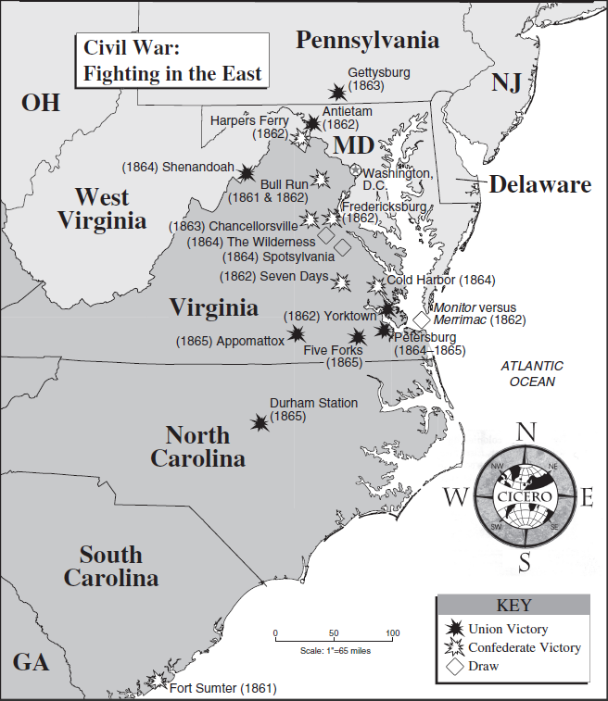

Directions: Use the information provided in the map on the next page to answer the following questions.
- Which army won the Battle of Fort Donelson? _________________________

- Which army won the Battle of Chattanooga? _________________________

- Which army won the Battle of Memphis? _________________________

- Which army won the Battle of Vicksburg? _________________________

- Which army won the Battle of Atlanta? _________________________

- List the years in which the following battles took place.
Perryville | _________________ | Nashville | _________________
Jackson | _________________ | Murfreesboro | _________________
Vicksburg | _________________ | Chattanooga | _________________

- Use the ruler and scale provided to determine the distance in miles between the following battlefields.
Perryville to Fort Henry | _______________
Mobile Bay to Jackson | _______________
Shiloh to Chickamauga | _______________
Vicksburg to Port Hudson | _______________

