The Changing Face of Women
Compare these two images from 1943 of a woman war worker. The one on the left was painted by Norman Rockwell and appeared on the cover of the popular weekly magazine Saturday Evening Post. Graphic artist J. Howard Miller for the Westinghouse Corporation produced the one on the right.
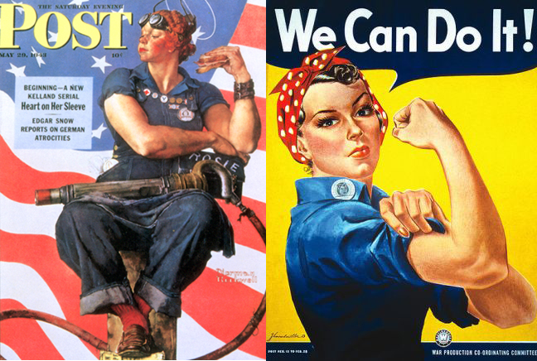
Rockwell’s woman has a big, muscular body and a dirty face. She holds her rivet gun and her lunch box with the name Rosie in her lap. Her feet are resting on a copy of Hitler’s Mein Kampf. The woman in Miller’s image has fingernail polish, lipstick, rouge, plucked eyebrows and mascara. She is wearing a bandanna and a work shirt and her company’s identification button.
What is Propaganda?
The widespread, systematic promotion of particular ideas, doctrines, or practices. All governments used propaganda to educate, inspire, and encourage their citizens to support the war effort. The U.S. government produced posters, pamphlets, newsreels, radio shows, even comic books to rally the country’s spirit and resolve.

Directions: Answer the following questions about the two depictions of Rosie the Riveter.
1. What do these two women have in common?
2. How do they differ?
3. Which image do you think became more popular with the public during the war? Why?
4. How do these images go against the usual portrayal of women during the era?
5. Which image do you like better? Why?
6. What was the purpose of these images?
7. Do these images fit the definition of propaganda? Why or why not?

